## Overall Project status from Start to End

Report Date 2024-10-01 Project Type :Non Construction

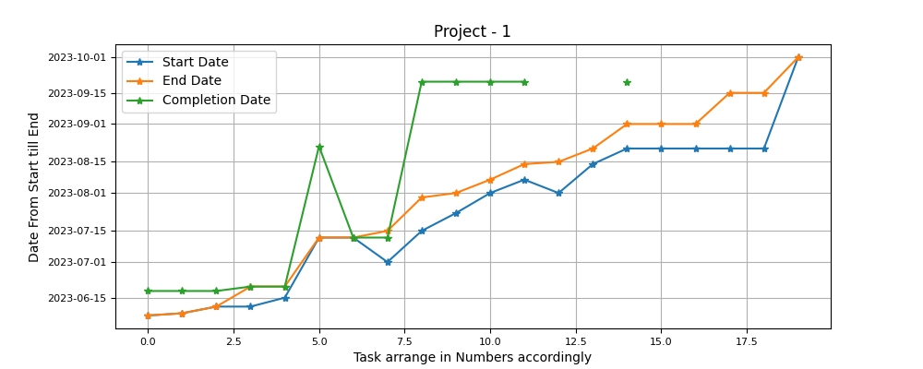

Project Detail View from start untill today can be observed. Star Marked are Tasks According to there Planned, Start and End Date and Actual Completion. Variance between the Planned Closed date and Actual Closed Date are clearly visible.

## Progress Delayed Items

##### Following items effected the progress performence

|  |  |  |  |
| --- | --- | --- | --- |
| Project Task Name | End Date | Completion Date | Extra Days |
| Subtask 1 | 2023-06-07 00:00:00 | 2023-06-18 00:00:00 | 11 days 00:00:00 |
| Subtask 2 | 2023-06-08 00:00:00 | 2023-06-18 00:00:00 | 10 days 00:00:00 |
| Subtask 3 | 2023-06-11 00:00:00 | 2023-06-18 00:00:00 | 7 days 00:00:00 |
| Subtask 6 | 2023-07-12 00:00:00 | 2023-08-22 00:00:00 | 41 days 00:00:00 |
| Subtask 9 | 2023-07-30 00:00:00 | 2023-09-20 00:00:00 | 52 days 00:00:00 |
| Subtask 10 | 2023-08-01 00:00:00 | 2023-09-20 00:00:00 | 50 days 00:00:00 |
| Subtask 11 | 2023-08-07 00:00:00 | 2023-09-20 00:00:00 | 44 days 00:00:00 |
| Subtask 12 | 2023-08-14 00:00:00 | 2023-09-20 00:00:00 | 37 days 00:00:00 |
| Subtask 15 | 2023-09-01 00:00:00 | 2023-09-20 00:00:00 | 19 days 00:00:00 |